Week 7: SQL Query Implementation for E-Commerce Database
.

Tasks to be Done:
- Perform Basic SQL
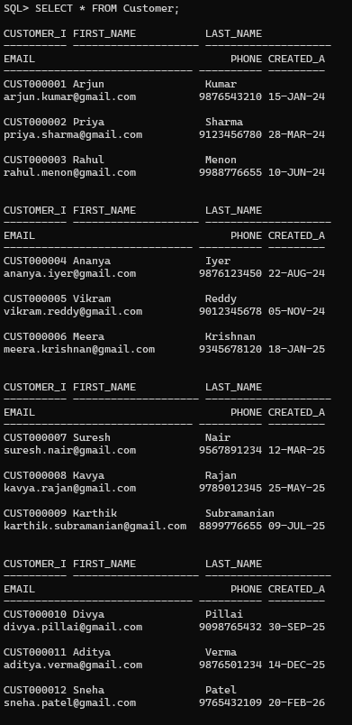
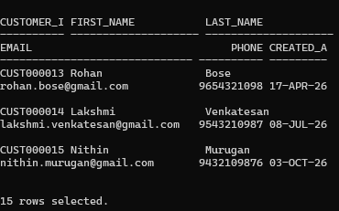
  - Display all customer details.

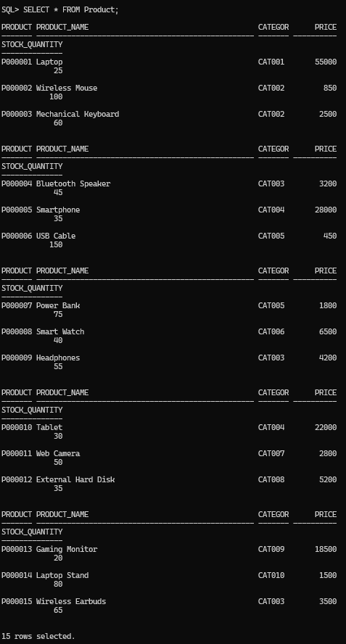
  - Display all available products.
  - Retrieve product names and prices only.
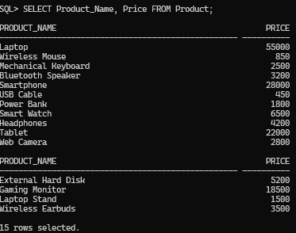
  - Display all orders placed by customers.

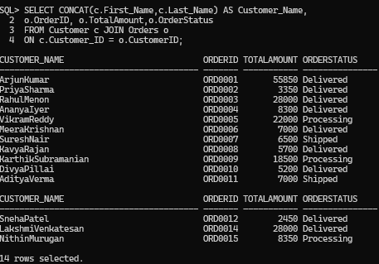
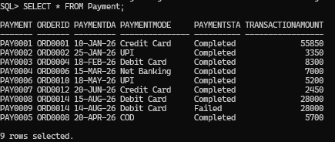
  - Retrieve payment details.

Apply Filtering Conditions Using WHERE
- Find products with price greater than ₹5000.
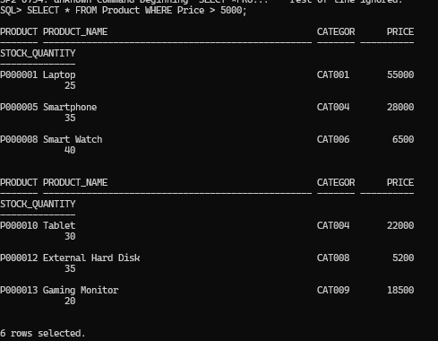
- Display products available in stock.

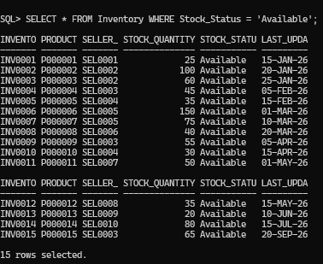
- Display completed orders.
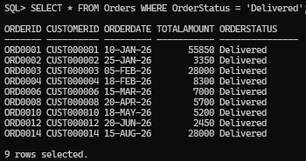
- Find products with rating above 4.
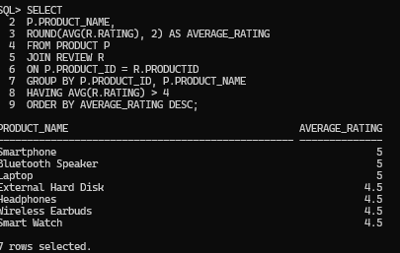

Sort Data Using ORDER BY Tasks:
  - Display products from lowest to highest price.

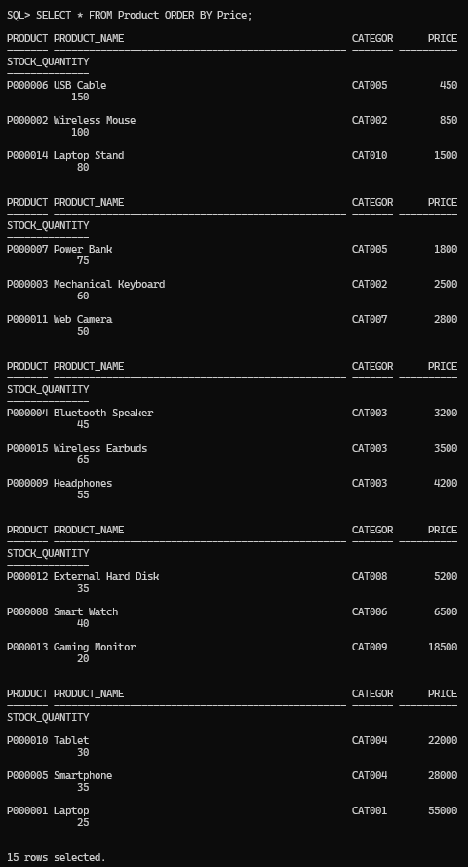
  - Display customers alphabetically.

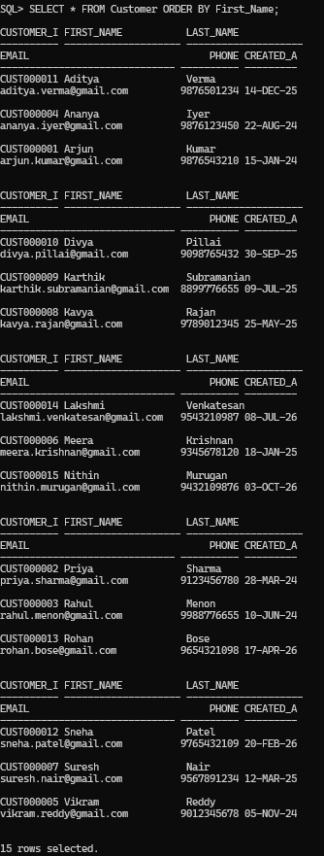
  - Find top expensive products.

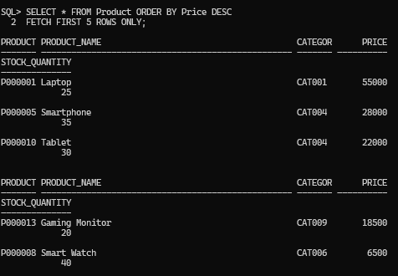
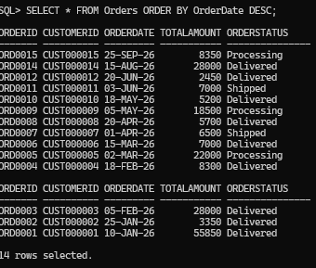
  - Display latest orders first.

Retrieve Unique Values Using DISTINCT Tasks:
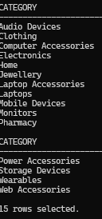
  - Display unique product categories.

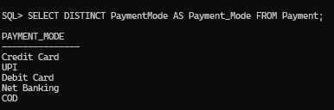
  - Find different payment methods used by customers.

Search Products Based on Conditions Tasks:
Write SQL queries to:

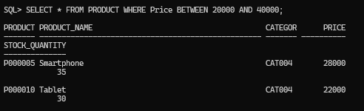
  - Find products within a specific price range. (Product Between 20,000 to 40,000)

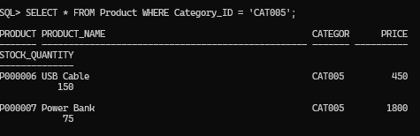
  - Display products belonging to a particular category.
  - Find products currently available in inventory.
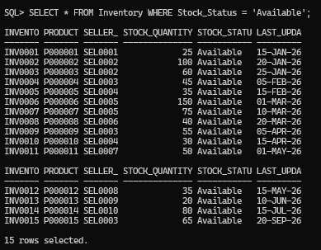

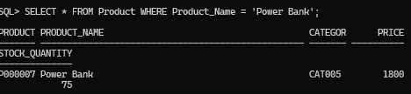
  - Search products using product name.
  - Find low-stock products.
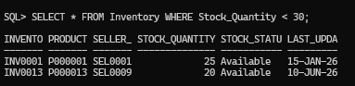

Retrieve Customer and Product Information Tasks:
  - Display customer details with their orders.
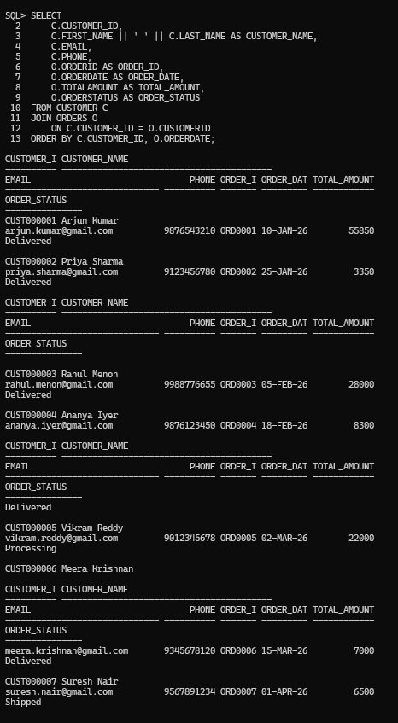

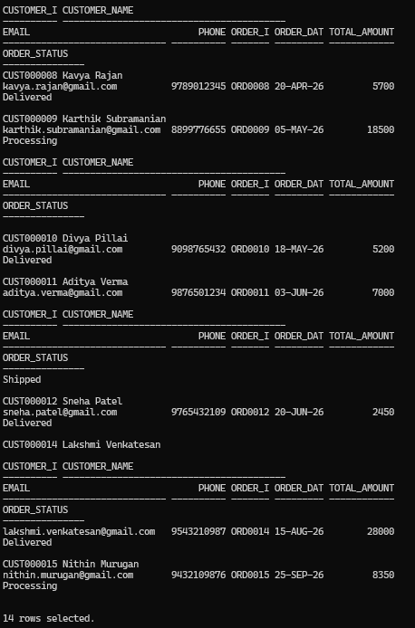
  - Display product details with category information.

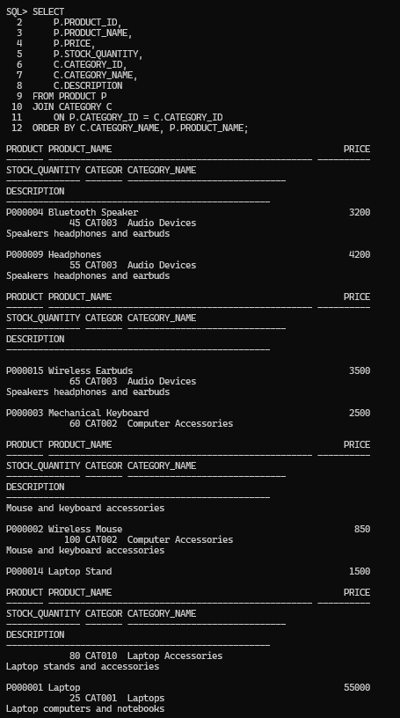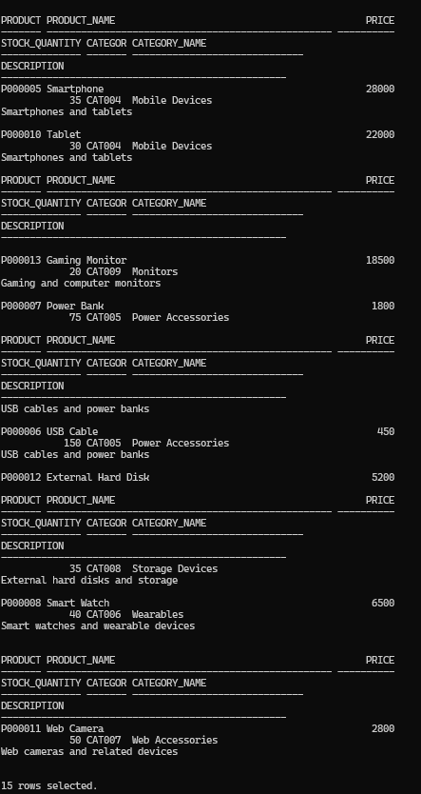

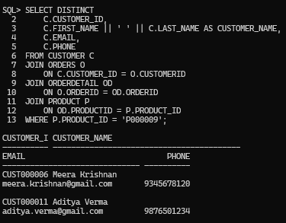
  - Find customers who purchased a specific product.
  - Display products purchased by each customer.
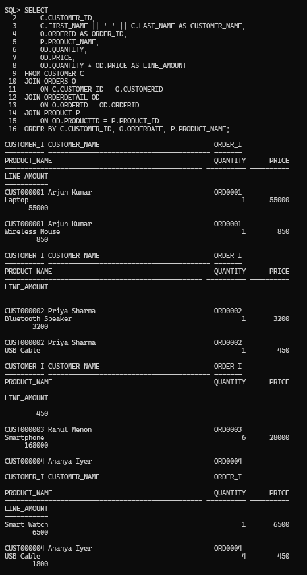

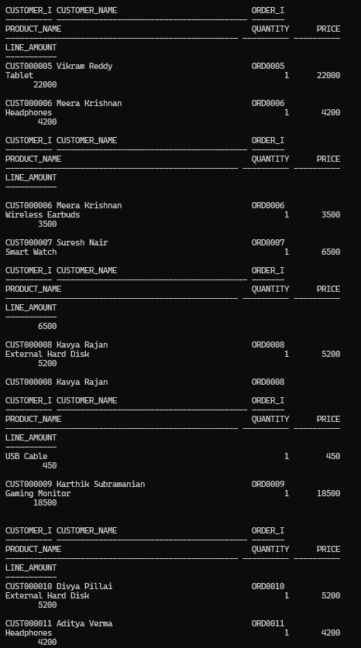
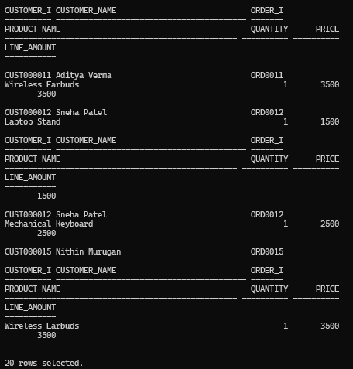

Apply Multiple Filtering Conditions Tasks:
  - Find electronics products costing more than ₹10000.

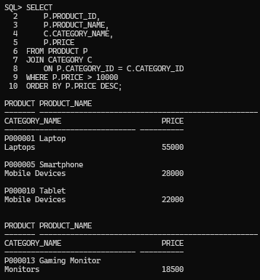
  - Search products containing the word "Mobile".
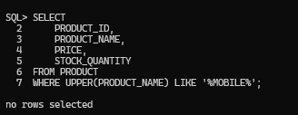
  - Find orders placed within a specific date range.
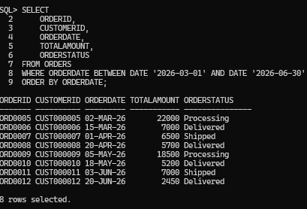

Generate Basic Business Reports Report 1: Product Availability Report Display:
- Product name

- Price
- Stock quantity
- Availability status
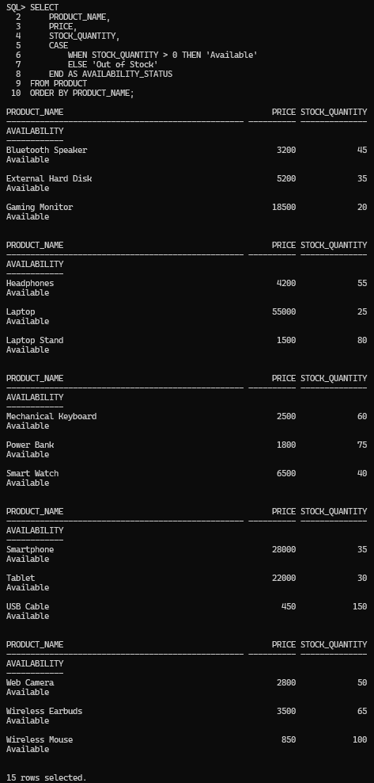

Report 2: Customer Report
Generate:
- Total number of customers
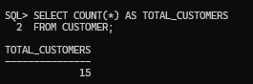
- New customer registrations
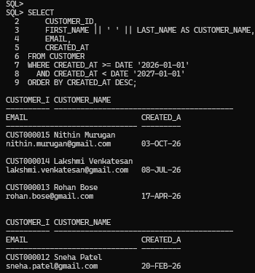

Report 3: Order Report
Display:
- Total orders
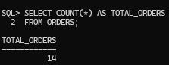
- Completed orders
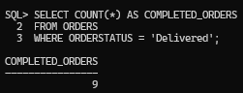
- Pending orders
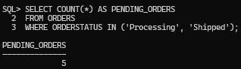

- Cancelled orders
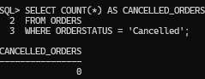

Report 4: Product Performance Report
Find:
- Highest-priced products
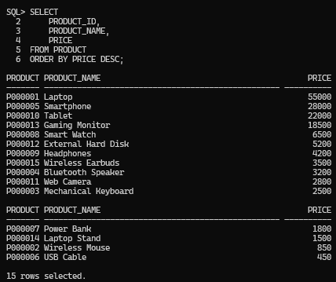
- Most reviewed products
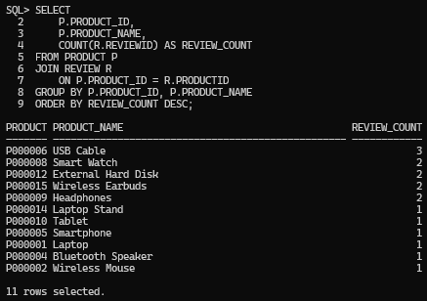
- Available products



